32

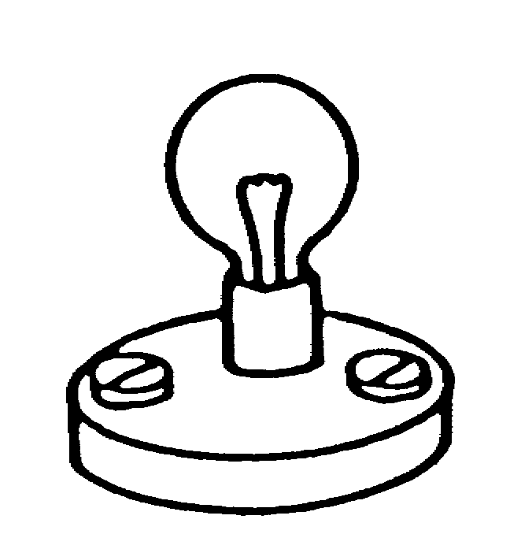
In this circuit, a bulb is connected to
Battery
a battery. The bulb is lit.

Below are several sentences about this circuit. Each has a word missing.
For each sentence, choose the best word to fill the gap.
Tick one box () to show the word you have chosen.

(a) When the bulb lights, there is ___________________ going through it. | ❑ | electricity
 | ❑ | an electric current
 | ❑ | energy
 | ❑ | voltage
(b) While the circuit is switched on, __________________ flows round, from the battery to the bulb, through it, and back to the battery. | ❑ | electric charge
 | ❑ | energy
 | ❑ | electricity
 | ❑ | voltage
(c) This flow is caused by the ___________________ across the terminals of the battery. | ❑ | power
 | ❑ | electric charge
 | ❑ | voltage
 | ❑ | electricity
(d) While the circuit is switched on, __________________ is constantly being transferred from the battery to the bulb and on into the environment. | ❑ | electric charge
 | ❑ | electric current
 | ❑ | energy
 | ❑ | electricity
(e) The longer the circuit is left switched on, the less ________________ the battery contains. | ❑ | electric charge
 | ❑ | electric current
 | ❑ | energy
 | ❑ | electricity

